Order Of Service

Singing: Psalm 16—CW page 68

Reading: Psalm 105:1-11

Opening Hymn: TLH 23

Reading: Acts 21:37-40

Request Hymn: CW Supplement 702

Reading: Matthew 9:14-17

Sermon Hymn: TLH 421

Sermon Text: Mark 8:34-38

Following Christ
Prayer

The Apostles’ Creed, TLH page 12

Holy Communion

The Lord's Prayer

The Blessing

Closing Hymn: TLH 45

* * * * * * * * * * *

Bible Study: Lambs: Honeybee
Sheep: Proverbs 19:16-20
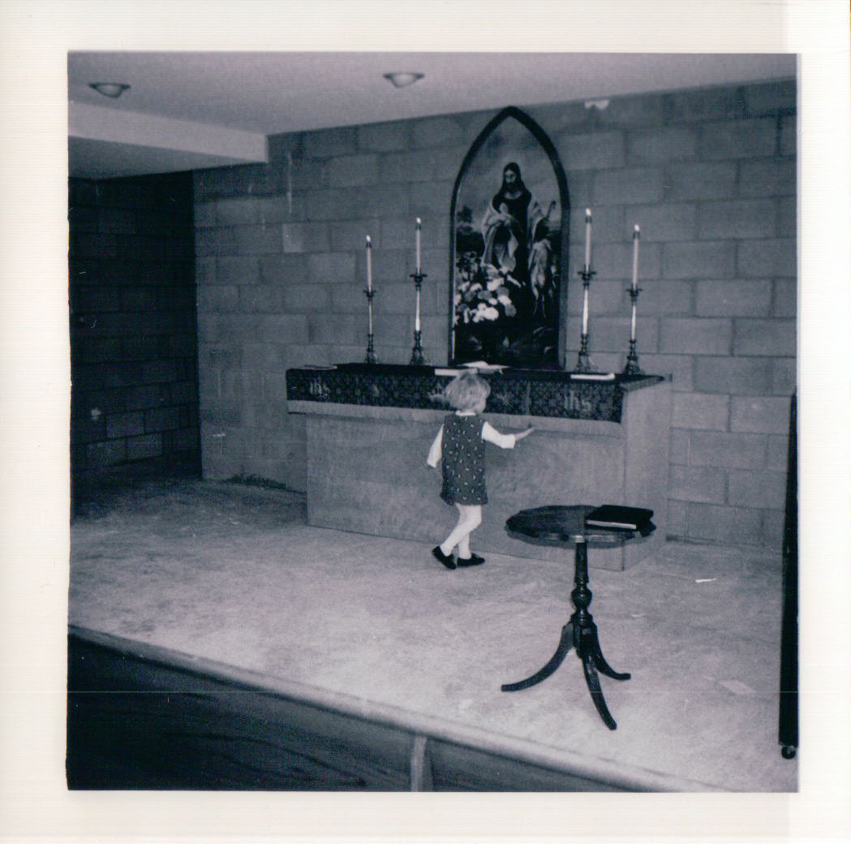

Shepherd Of The Hills, Duluth, MN

Water
Of
Life

11 August 2019

W A T E R O F L I F E

Independent Christian Church—Conservative Lutheran Doctrine

Worship Service: 9:30 a.m. Bible Study: 10:45 a.m.

Larry Cooper, Pastor E-Mail address:
111 N. Ridge Road lcooper@wateroflife.cc
Coon Valley, WI 54623 Web Site:
www.wateroflife.cc

* * * * * * * * * * * * * * * * * * * * * * * * * * *

Sermon Text: Mark 8:34-38

Following Christ

* * * * * * * * * * * * * * * * * * * * * * * * * * *

Mark 8:34 And when he had called the people unto him with his disciples also, he said unto them, Whosoever will come after me, let him deny himself, and take up his cross, and follow me.
:35 For whosoever will save his life shall lose it; but whosoever shall lose his life for my sake and the gospel's, the same shall save it.
:36 For what shall it profit a man, if he shall gain the whole world, and lose his own soul?
:37 Or what shall a man give in exchange for his soul?
:38 Whosoever therefore shall be ashamed of me and of my words in this adulterous and sinful generation; of him also shall the Son of man be ashamed, when he cometh in the glory of his Father with the holy angels.

Rights & Benefits—A Good Deal!

Spirit: I have delivered you from the slavery of Satan and brought you to a new Master.

Me: So what are my rights?

Spirit: You have no rights. You were bought with a price.

Me: What was the price my Master paid for me?

Spirit: He shed his blood for you to forgive your sins. Now you belong to him.

Me: I don’t deserve that. Why did he die for me?

Spirit: Because he loves you.

Me: I don’t deserve that, either.

Spirit: Don’t you want to know what your benefits are?

Me: I didn’t know I had any benefits.

Spirit: But you do! Your new Master will guide your life, and work everything for your good.

Me: That sounds almost too good to be true.

Spirit: There is more! You will live with him forever in his Kingdom of Glory!

Me: That is a good deal!

